Theoretical Lexicon

What is Theoretical Lexicon
# Source: AI Source: Provided by: [Data Path: Persons Table -> ID Column: 1, Name_En Column: Motasem Essam] -> From: [Chatgpt (GPT-4-turbo)] on [7/29/2025]
A Theoretical Lexicon is a formalized set of lexical entries used in linguistic theory to describe and analyze the structure and behavior of words in a language. Unlike mental or dictionary lexicons, which are about storage or practical usage, the theoretical lexicon is a conceptual tool used in models of syntax, morphology, and semantics.

🔹 Key Features of Theoretical Lexicon:
# Source: AI Source: Provided by: [Data Path: Persons Table -> ID Column: 1, Name_En Column: Motasem Essam] -> From: [Chatgpt (GPT-4-turbo)] on [7/29/2025]
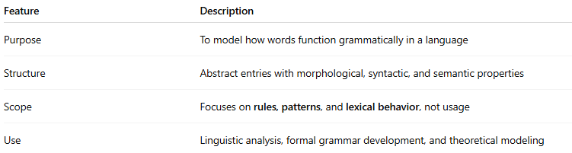
Feature | Description
Purpose | To model how words function grammatically in a language
Structure | Abstract entries with morphological, syntactic, and semantic properties
Scope | Focuses on rules, patterns, and lexical behavior, not usage
Use | Linguistic analysis, formal grammar development, and theoretical modeling

🔹 What Does a Theoretical Lexicon Contain?
# Source: AI Source: Provided by: [Data Path: Persons Table -> ID Column: 1, Name_En Column: Motasem Essam] -> From: [Chatgpt (GPT-4-turbo)] on [7/29/2025]
Each lexical entry includes detailed formal features such as:
- Lexeme: e.g., run
- Phonological form: /rʌn/
- Morphological info: e.g., irregular past tense (ran)
- Syntactic category: verb (V), noun (N), etc.
- Subcategorization frame: what arguments the word requires
run [intransitive] vs. run [transitive]
She runs. vs. She runs a company.
- Semantic features: agent, action, patient roles
e.g., [Agent X] runs [Theme Y]

🔹 Example of a Lexical Entry (Simplified)
# Source: AI Source: Provided by: [Data Path: Persons Table -> ID Column: 1, Name_En Column: Motasem Essam] -> From: [Chatgpt (GPT-4-turbo)] on [7/29/2025]
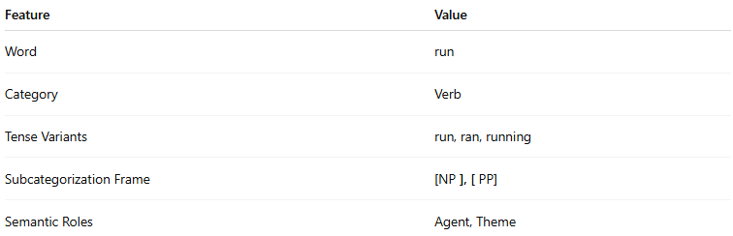
Feature | Value
Word | run
Category | Verb
Tense Variants | run, ran, running
Subcategorization Frame | [NP ], [ PP]
Semantic Roles | Agent, Theme
This tells us that run can take a noun phrase (run the show) or a prepositional phrase (run to the store), and assigns roles to participants.

🔹 Theoretical Lexicons Are Used In:
# Source: AI Source: Provided by: [Data Path: Persons Table -> ID Column: 1, Name_En Column: Motasem Essam] -> From: [Chatgpt (GPT-4-turbo)] on [7/29/2025]
- Syntax theories (e.g., Generative Grammar, LFG, HPSG)
- Morphology models (e.g., Distributed Morphology)
- Formal semantics (truth conditions, predicate logic)
- Computational modeling (underlying structure for parsers)

🔹 Theoretical vs Other Lexicons
# Source: AI Source: Provided by: [Data Path: Persons Table -> ID Column: 1, Name_En Column: Motasem Essam] -> From: [Chatgpt (GPT-4-turbo)] on [7/29/2025]
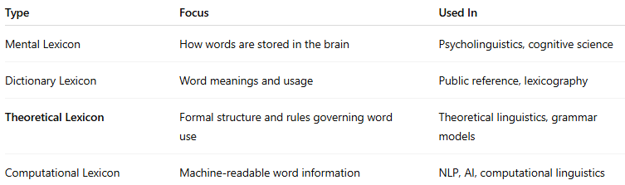
Type | Focus | Used In
Mental Lexicon | How words are stored in the brain | Psycholinguistics, cognitive science
Dictionary Lexicon | Word meanings and usage | Public reference, lexicography
Theoretical Lexicon | Formal structure and rules governing word use | Theoretical linguistics, grammar models
Computational Lexicon | Machine-readable word information | NLP, AI, computational linguistics

